YOGA TEACHER TRAINING/CERTIFICATION
FOR CHILDREN AND TEENS
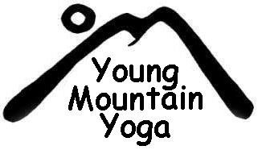

A Yoga Alliance approved certification course for parents, teachers or anyone who wants to teach yoga to young people.

THE NEXT SESSION KICKS OFF IN NOVEMBER 2017!
Module/Workshop Calendar 2017-18
Each module is a full weekend. There are no major holidays during the dates listed below.

Dates: | Saturday | Sunday
November 4-5 | 12:30-6:30 | 12:30-6:30
December 2-3 | 12:30-6:30 | 12:30-6:30
January 6-7 | 12:30-6:30 | 12:30-6:30
February 3-4 | 12:30-6:30 | 12:30-6:30
Module 5… TBD | 12:30-6:30 | 12:30-6:30

Participate in any one module... or take all five modules + practicum for a
full certification. If you are interested but some dates don't work, make up options are available.
*All five modules, mentorship and teaching practicum must be completed for certification.

Training modules will take place at Wainwright House

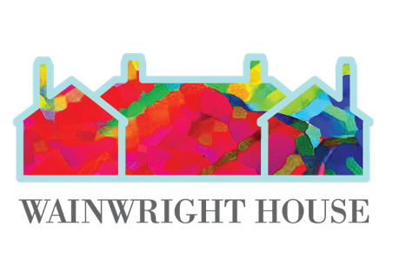
260 Stuyvesant Avenue, Rye, New York 10580

Let us know you are interested by emailing:
gabrielacolormeyoga@gmail.com or registrar@wainwright.org

